Lab – How Connected are You?

1. Objectives

Survey 3 or 4 people: family, colleagues, and friends. Determine how many hours they are "connected" via any device during each day.

1. Background / Scenario
2. It is important to understand that most people born in the 1990s, will have grown up in a primarily digital world. Computers, the Internet, mobile phones, texting, social networking are all second nature to members of this group. This survey will help you to recognize how much of the day is actually spent “connected”. This will help us to see the impact this generation will have on business and the economy.
3. Required Resources

* 3 or 4 people (friends, family, colleagues)
  1. Create a spreadsheet similar to the one below.
     1. Add extra rows for more information if needed.

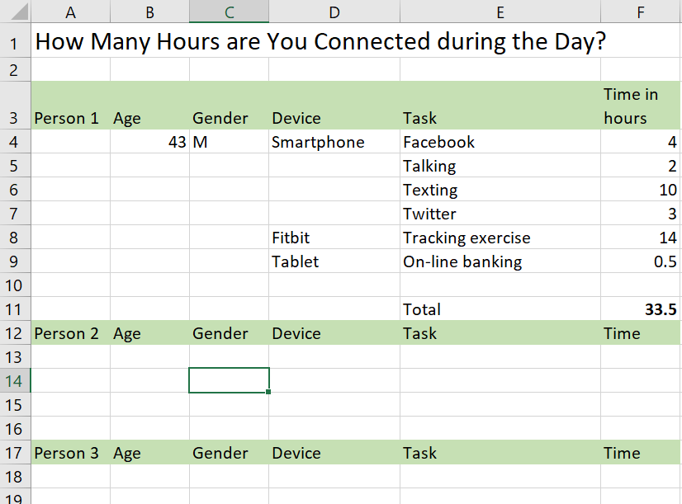

* 1. Summarize findings.

1. What was the average amount of time spent “connected” by all of your interviewees?  
     
   Thời gian trung bình khoảng 6 giờ.
2. How many people were connected on more than one device at a time?  
     
   2 người
3. Did age make a difference to the amount of “connected” time during a day? If yes, what do you think is the reason?  
     
   Có. Vì lứa tuổi, công việc khác nhau sẽ có nhu cầu sử dụng mạng khác nhau.
4. Did gender make a difference to the amount of “connected” time during the day? If yes, what do you think is the reason?  
     
   Không
5. How might this information affect the way businesses address their processes?  
     
   Thông tin có thể giúp thống kê, nắm bắt nhu cầu của người dùng ở từng giới tính và độ tuổi khác nhau để hướng đến phát triển kinh tế.